
Enchanting "SeaMagic Sidley" is a roaring success.
The sun finally came out for SeaMagic Sidley, which took place last Saturday August 12th. Locals came out in their droves to Sidley recreation ground to enjoy the free community fun day which included sea themed performances and activities for all to enjoy.
The event brought together local and international performers including The Show Globe’s “Sea Sphere” which mesmerised audiences young and old and “The Penguins” by Creature Encounters, whose delightful interactions were a real crowd pleaser. Storytellers Xanthe Gresham and Kate Daisy Grant captivated the imagination with their maritime tales, plus well-known local performers entertained the crowd including Ben Watson as compere, stilt walker Dolly Delicious, hula artist Xena Flame and Stix Drummers. Local talent was very much displayed through the skilful majorette group Tornado Twirlstars and the dazzling Morris dancers Rheda’s Dream.
Photo by: Sara-Louise Bowrey
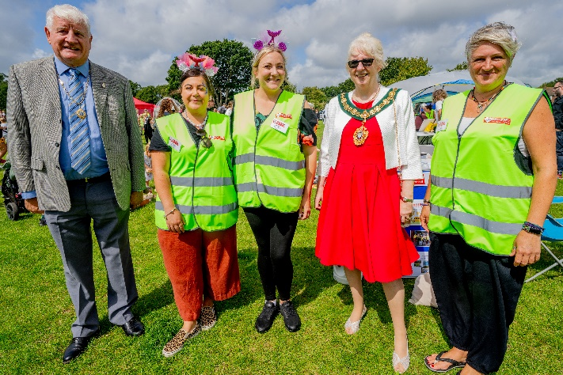
Mermaids, sea monsters, sailors and pirates participated in the parade led by Stix Drummers with the Mayor of Bexhill Lynn Brailsford and Cllr Sam Coleman judging the much-anticipated costume competition.
There was a scrumptious BBQ organised by the Scouts and a number of local community stalls, who presented a host of engaging activities for children, including face painting and arts & crafts, ensuring there was something for everyone to enjoy.
The Mayor of Bexhill with Heart of Sidley

“A huge thank you to each and every one of our fabulous volunteers on the day, to the 18hours team, and to every single one of you who attended, supported and donated to our event, we hope you enjoyed it as much as we did!”
Heart of Sidley

SeaMagic Sidley is supported by Heart of Sidley and produced by 18 Hours.

