FOR IMMEDIATE RELEASE
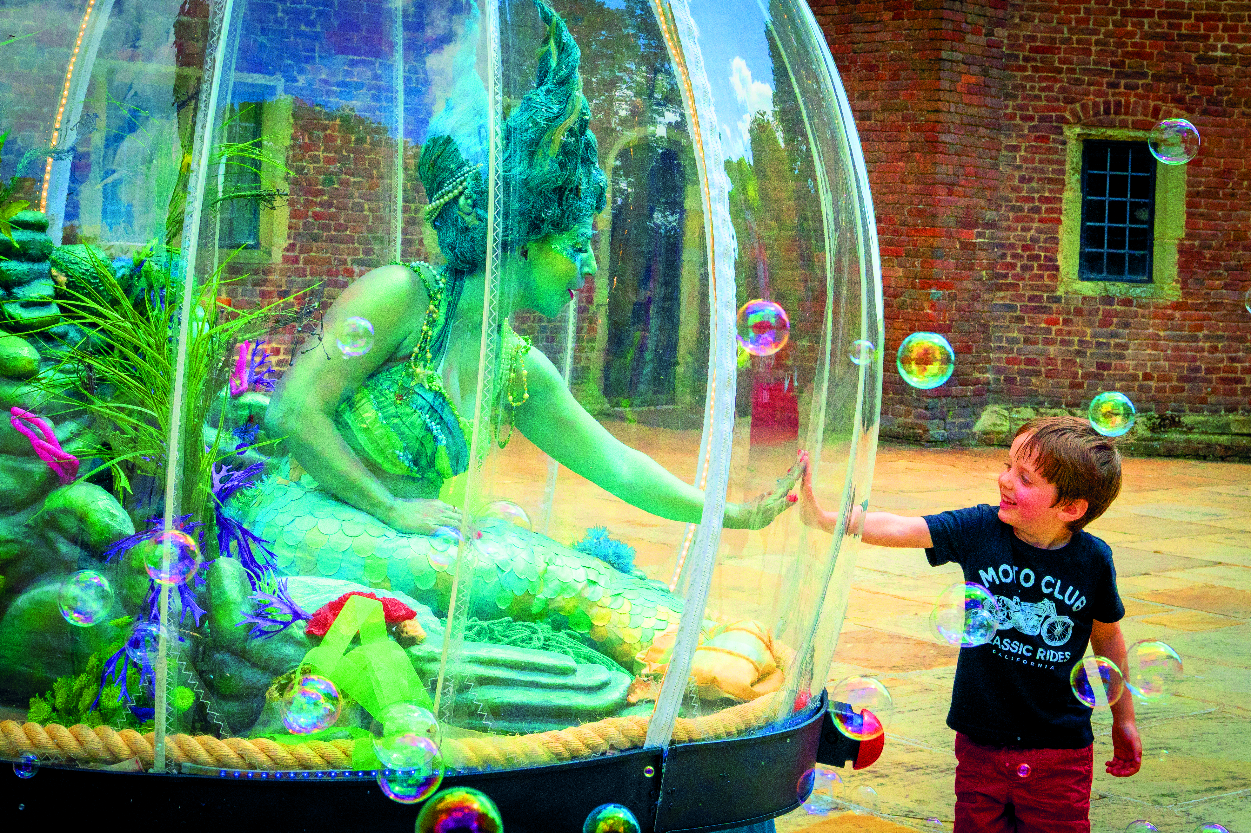
SeaMagic: Sidley - A spectacular FREE festival uniting the community

SeaMagic: Sidley, the highly anticipated free community festival held on Sidley Recreation Ground, is ready to dazzle attendees with captivating performances, exhilarating activities and storytelling on August 12th. The event will be produced by local events company 18 Hours on behalf of Heart of Sidley.

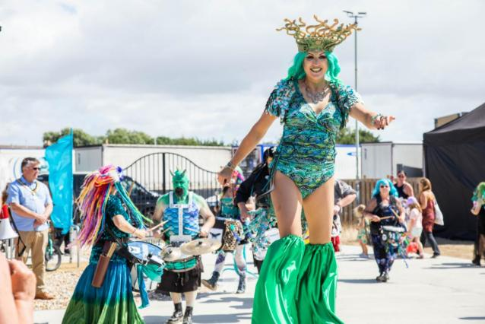
Prepare to be wowed by The Show Globe's enchanting "Mermaid" performance as they transport you to a world of wonder. Feel the pulse of the vibrant beats by local drummers, Stix Drummers, as their rhythms ignite the energy of the crowd. Join Xena Flame's Hula Hooping workshop and unleash your hula hooper. Let your imagination soar with face painting and embrace your favorite characters. And don't miss the delightful "Penguin Family" by Creature Encounter, bringing joy to all with their adorable antics.

Xanthe Gresham and Kate Daisy Grant will be taking you with them as they tell tales that will transport you to another world. One of the festival highlights is the not-to-be-missed parade, where creativity takes center stage. Be part of the dress-up competition and transform into a mermaid, sea monster, pirate, sailor, fish-folk, or smuggler. Exciting prizes await the most imaginative costumes, adding an extra layer of excitement to this vibrant event. As you explore the festival grounds, you'll discover local community stalls brimming with activities.
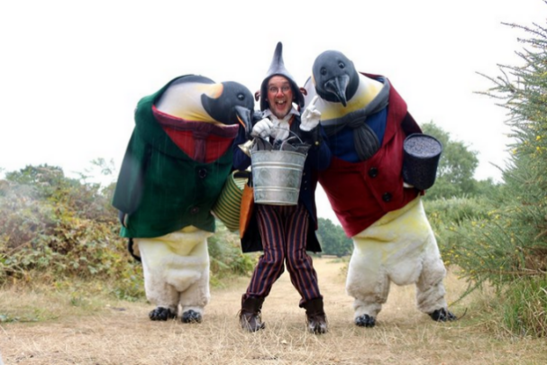
For more information and updates about SeaMagic: Sidley, please visit our website at https://heartofsidley.co.uk/.

END
Press Images here: https://www.dropbox.com/sh/ctf9wcgao3nut05/AACqOxa-xvl4tkg9TOGomEBna?dl=0

